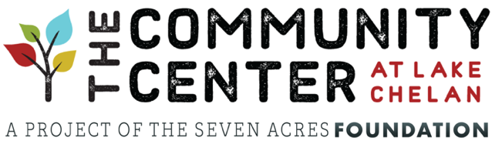
NEWS RELEASE

FOR IMMEDIATE RELEASE
FOR FURTHER INFORMATION CONTACT:
Ben Williams – Board President – Seven Acres Foundation
ben@sevenacresfoundation.org

SEVEN ACRES FOUNDATION RECEIVES MULTI-MILLION
DOLLAR GRANT FROM STATE LEGISLATURE

Community Center at Lake Chelan Awarded $2.5 Million
From Building Communities Fund

CHELAN, Washington (May 21, 2021) – Seven Acres Foundation, developers of the forthcoming Community Center at Lake Chelan (CCLC), has revealed that their grant proposal to the Washington State Legislature has been fully funded at $2.5 million.

In making the announcement, Seven Acres board president, Ben Williams, said their board received the great news a few weeks ago at the conclusion of this year’s legislative session in Olympia. “We were all dying to shout this from the rooftops right away, but we were advised to hold off on that until Governor Inslee officially signed the state’s budget. Now that he’s done so, we can finally let everyone know what an amazing development this is for our Community Center. Receiving this multi-million dollar grant serves as a springboard to begin actual construction of the facility, which I know everyone is very eager to see. Raw material costs, most notably steel and lumber, have skyrocketed over the last several months, so news of this major grant couldn’t come at a better time.” Williams also extended special thanks to State Representative, Mike Steele, for his continued strong support of the grant. He also praised the tireless efforts of the Seven Acres Executive Director, Raye Evans, as well as the board’s outside fundraising consulting firm, Westby Associates (Vancouver, WA).

The grant comes out of the state’s Building Communities Fund program, which was established by the Legislature back in 2008. The program awards state grants to nonprofit, community-based organizations to defray up to 25 percent or more of eligible capital costs to acquire, construct, or rehabilitate nonresidential community and social service centers. It is funded through the sale of state bonds with no assistance from the federal government. Grantees are selected through an extensive and highly competitive grant application process conducted every two years by the Washington State Department of Commerce.

- more -

For an organization/project to be considered, it must meet ten different specific criteria, including requirements such as offering “a diverse set of on-site activities that meet multiple community service objectives,” as well as increasing “the range, efficiency or quality of the services provided.” In addition, the project must “reflect a long-term vision for the development of the community, shared residents, businesses, leaders, and partners.”

To learn more about or donate directly to the Community Center at Lake Chelan, please go to www.ccatlakechelan.org or contact Raye Evans, Executive Director of the Seven Acres Foundation at raye@sevenacresfoundation.org. For additional information on the Building Communities Fund, visit www.commerce.wa.gov/building-infrastructure/capital-facilities/building-communities-fund.

###

